**Base Code (Version 1)**

We created below model to begin with and applied it on 101 images, 76 in training and 25 in validation.

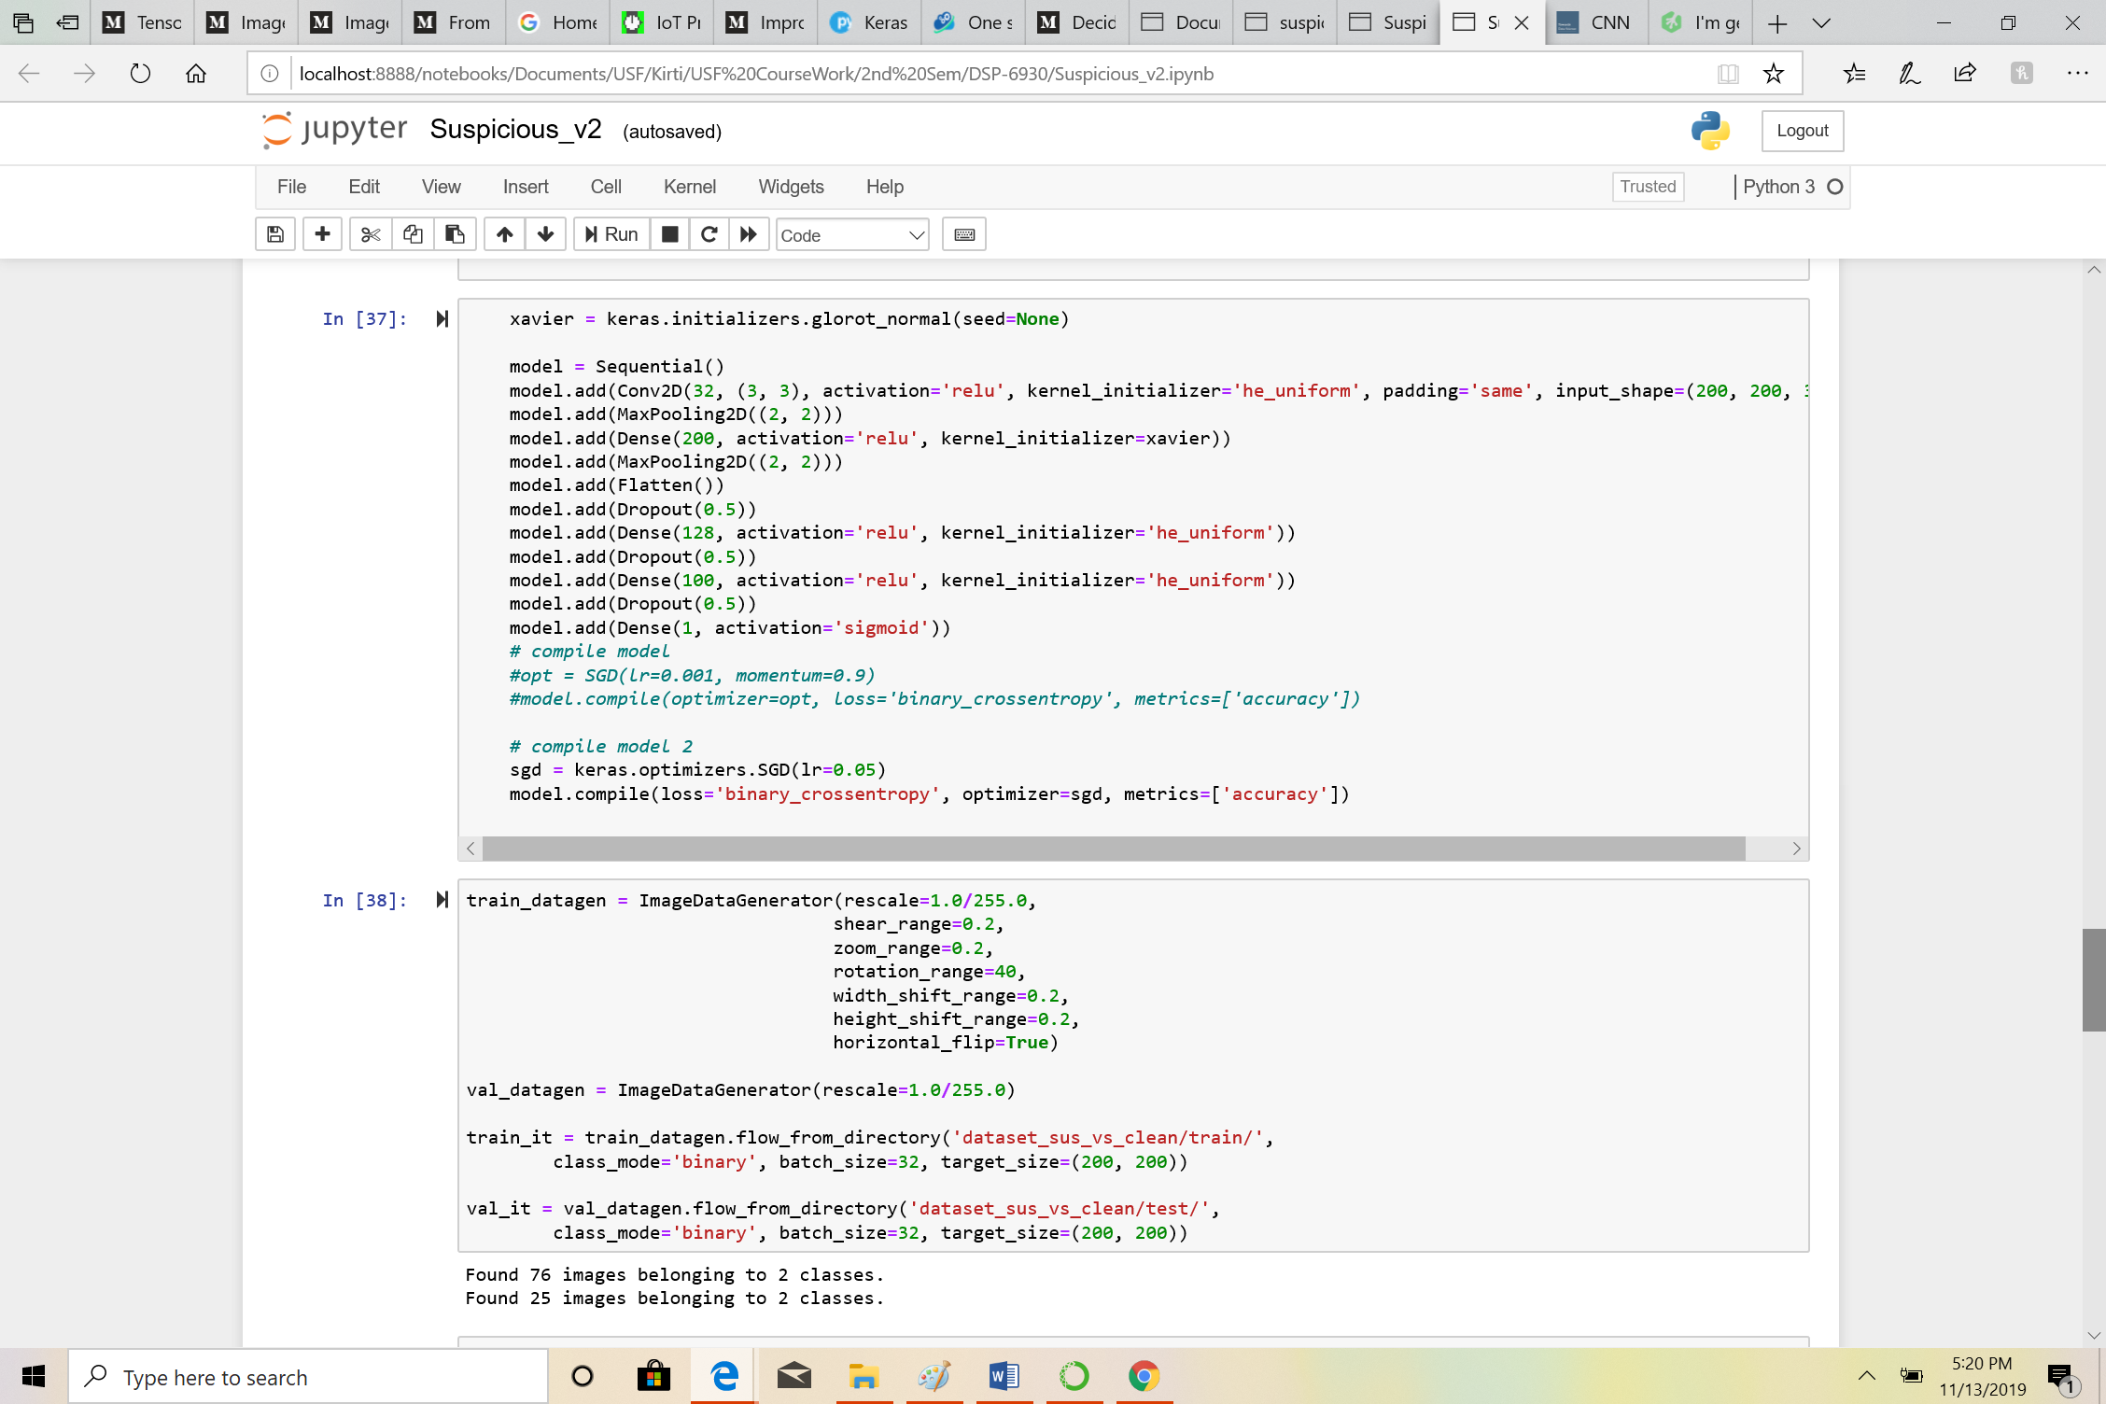

Used epochs = 20, training steps per epoch = 25 and 30 in validation steps and got accuracy of 61-62% and validation accuracy of 36%.

